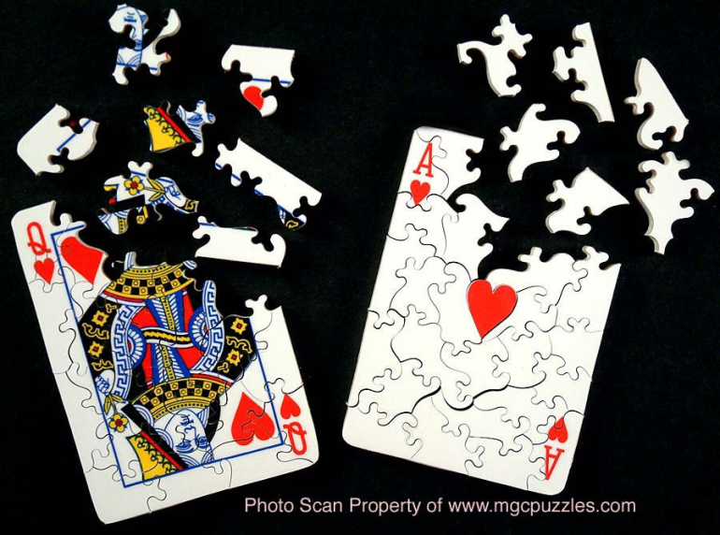

|  |  |  |
| --- | --- | --- |
| **Is it a puzzle**  **or is it a game**  **of cards?** | | |
|  |  |  |
| **Learn to play Bridge…**  **the best card game in the world!** | | |
| **Karori Bridge Club**  **274 Karori Road, Karori**  **Lessons start: Wednesday, 29 June 2022 at 7:30pm**  To register, please phone 04 476 6179 or email [karoribridge@gmail.com](mailto:karoribridge@gmail.com)  Visit our website: [www.karoribridge.com/lessons.html](http://www.karoribridge.com/lessons.html)  This 10-lesson course runs over a period of eleven weeks with a week’s playing only session in the middle. The lessons include lots of card play and comprehensive course notes. The two-hour lessons are held weekly on Wednesdays. The cost of $60 will be deducted from your membership fee to 31 May 2023 when you join the club.  **Bring along a friend, a partner or just yourself!** | | |